
Why Two Stories? Evaluate Interpretation

Do not encourage “Chinese whispers” explanation with their being one true version gradually distorted (not correct). Always explain that some Christians believe the story is literally true, while most others take it metaphorically.
Show the PowerPoint Nativity two stories which children could watch with their Venn diagram in front of them. The PowerPoint helps to recap and place each event under either Matthew or Luke. When all the statements are placed, it should look like this: *

Matthew | Luke
Supernatural sign of star  Important visitors from the East  Herod is jealous  Expensive gifts | Forced to go to the census  Visited by poor shepherds  Homeless – no room at inn  Baby laid in a feeding trough

Ask children how the 2 lists are different; they should notice than one (Matthew) seems to place Jesus’ birth as an important event, drawing kings and foreign visitors. The other portrays Jesus as a humbler. Explain that shepherds were among the lowest members of society - what is Luke implying when he tells that the news was given to them, not to the important people? What was he trying to say by the fact that Jesus was born homeless without even a bed? And what could Matthew be trying to say? Ask children for key-words which sum up the 2 lists: hopefully, they will come up with something like Power for Matthew and Poor, unimportant for Luke.

*On two final clicks, the words ‘Mighty’ (Matthew) and ‘Lowly’ (Luke) appear. Next slide is linked to final discussion.

DISCUSSION
Ask pupils: what events are the same in both stories? Children discuss in groups. They will come up with ideas such as: Mary & Joseph Jesus’ parents; there are angels in both stories; Jesus was born in Bethlehem; supernatural events took place; Jesus was God’s son who came down to earth. Receive ideas neutrally.
Because something can be interpreted 2 (or more) different ways is it less “real”? Can there be any one true version of anything? Activate final slide of PowerPoint which puts forward idea that the nativity story is disproved tomorrow in The Sun. (Opportunity here to discuss how newspapers interpret stories).
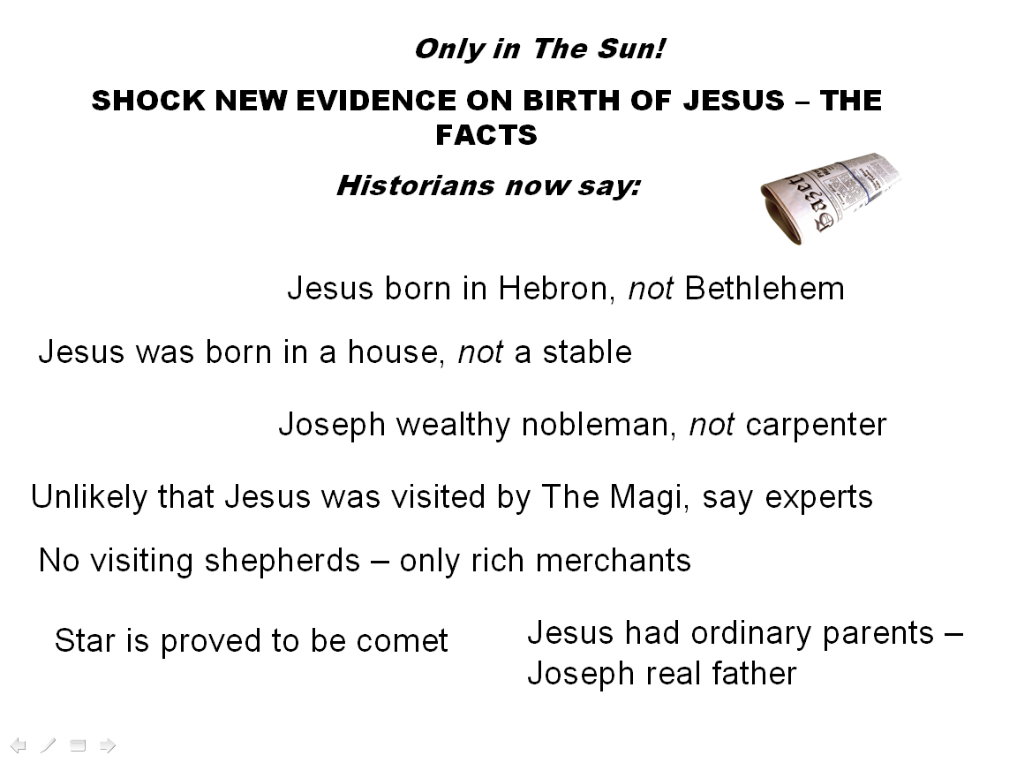

Two activities
Look briefly at the statements on the slide – eg What if it was discovered tomorrow that Jesus was born in a house? Children are given (in threes) the statement strips, as per slide, + cards saying Matthew’s interpretation would be spoilt, both interpretations would be spoilt , Luke’s interpretation would be spoilt. Children sort statements accordingly, under each card. For instance, if it was discovered that Joseph had been a nobleman, this would detract from Luke’s ‘spin’ on the story.
Finally, ask: would it matter to Christians? Which of the ‘shock evidence’ on the PowerPoint would matter least to Christians? Or most? Order them, using the scales provided (This wouldn’t matter at all to Christians; This would matter a lot to Christians).
If Christians could only keep one part of the story, what would they keep? (Answer: J is God’s son sent to earth). This is the ‘truth’ of the story for many Christians and should go in the middle of the Venn diagram. M & L interpreted the less important parts (‘trimmings’) of the story differently. Children record the main message for Christians on their diagram, making it look suitably important by giving it emphasis.


Reflect on the learning cycle and how we have changed our original ideas about interpretation. Finally, is there anything which is not open to interpretation? (A very philosophical debate!)

Mighty Matthew
Wise Men
Gifts – gold for kingship, incense for holiness, myrrh for death foreshadowed
Star
2nd Angel to Joseph telling him of Herod`s plan
Involvement of King Herod inc killing of the Baby Boys by Herod then have to run away to Egypt

Lowly Luke
Angel appears to Mary
Census (everyone ordered to home town to be counted)
Joseph & Mary travel to Bethlehem
No room at the inn
Jesus put in manger
Angels appear to shepherds (lowly members of society)
Shepherds visit Jesus

Both
Jesus is the Son of God
Mary & Joseph are his parents
They came from Nazareth
Jesus was born in Bethlehem
Special events happened at Jesus` birth

