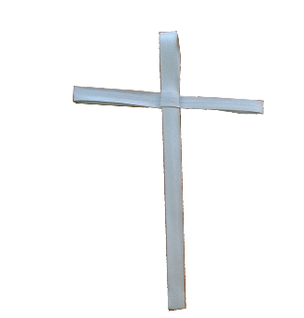
Name………………………………..

Palm Crosses

Eva is a Christian. In assembly, the children were all given palm crosses.
How would Eva like to see the crosses being treated?
What would make her happy?
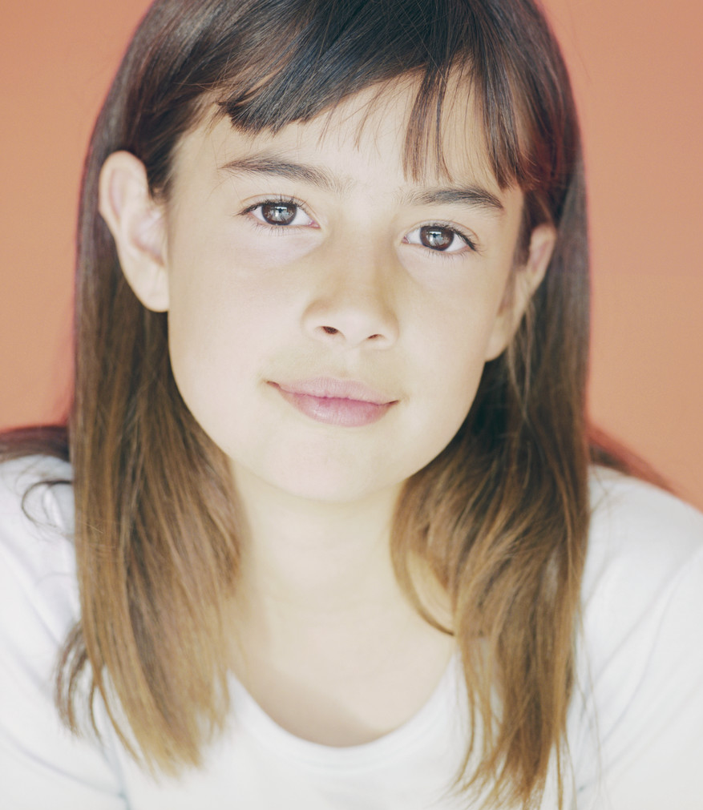
What would make her sad?
It makes me feel happy when

because
It makes me feel sad when

because

