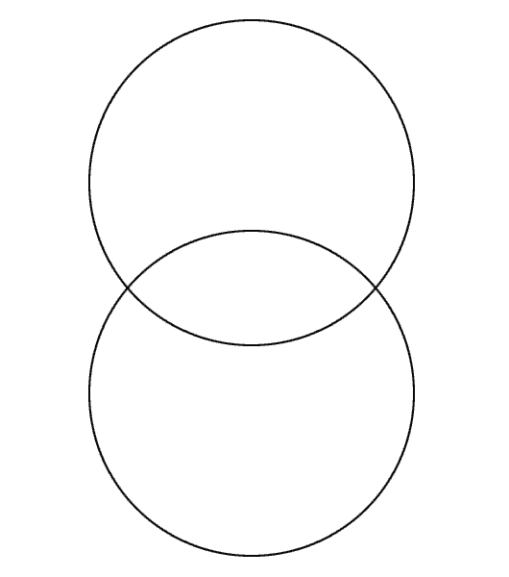
THE TWO BIRTH STORIES

Matthew Luke

