NOTICE OF DEMOLITION

Due to the construction of a new road, notice is given that
Jamia Mosque,
High Street
may have to be demolished and re-housed in a new building.
The Council invites your comments.


NOTICE OF DEMOLITION

Due to the construction of a new road, notice is given that
The Hampton Sikh Gurdwara,
High Street
may have to be demolished and re-housed in a new building.
The Council invites your comments.

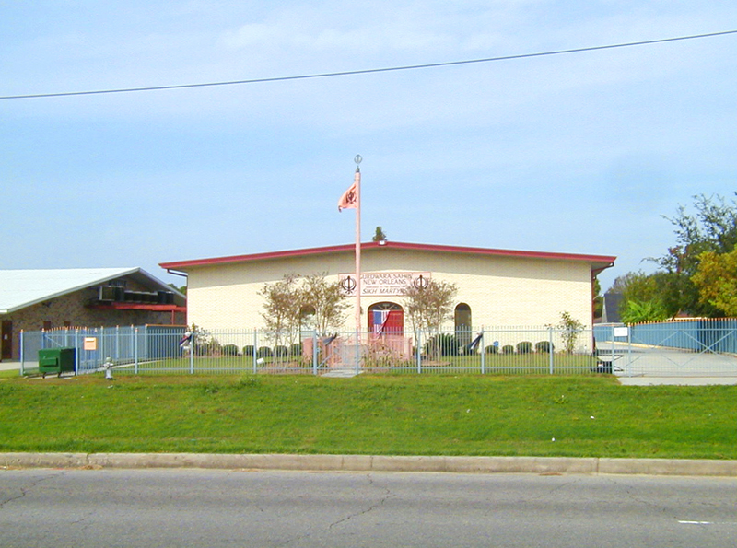
NOTICE OF DEMOLITION

Due to the construction of a new road, notice is given that
The Buddharama Temple,
High Street
may have to be demolished and re-housed in a new building.
The Council invites your comments.

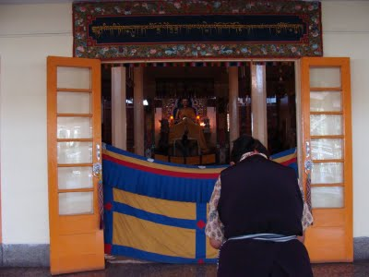
NOTICE OF DEMOLITION

Due to the construction of a new road, notice is given that
St Mary’s Church,
High Street
may have to be demolished and re-housed in a new building.
The Council invites your comments.

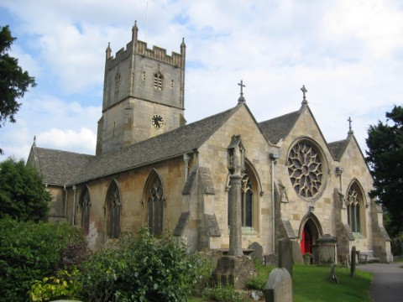
NOTICE OF DEMOLITION

Due to the construction of a new road, notice is given that
Radha Krishna Temple,
High Street
may have to be demolished and re-housed in a new building.
The Council invites your comments.

