The Rabbi and the Cow

By Shoshannah Brombacher
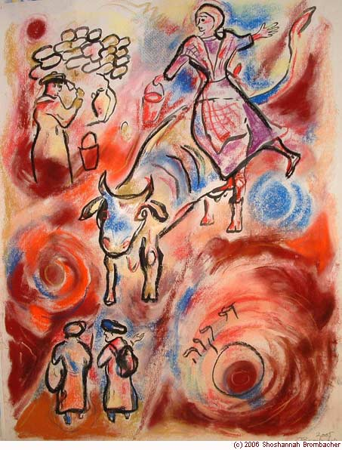
There was a Rabbi, a very good and pious man, who wanted to see justice in the world. But it often seemed to him that good people got punished and that bad or undeserving people thrived and prospered. He pondered about this and he found no solution for his problem.
Now this Rabbi used to study at night and sometimes he got a famous visitor, Elijah the Prophet.
"Come," said the prophet at such an occasion. "Tomorrow I wish to go out into the world. I want to see whether the Jews around here are still hospitable; I want to experience how they keep this great mitzvah of our father Abraham. I want you to go with me. We will disguise ourselves as filthy, haggard beggars and knock on doors. But no matter what happens, I want you to observe without asking me any questions or seeking any explanations."
And so it came to pass. They left the next morning and in the evening they came to a very poor hovel, hardly worthy of human occupation. They knocked and found that a poor farmer and his wife lived there together with a cow, their only possession, which provided their meager livelihood: they sold milk in the next village and drank what was left. It kept them from starving.
The farmer couple was poor but very friendly, and ushered the two "beggars" in. They let them sleep on their best straw (they had no beds) and they shared a slice of hard bread and a cracked bowl of milk from their cow with them. They entertained the guests with friendly conversation till they all said the nighttime prayers and went to sleep.
In middle of the night, the Rabbi noticed that Elijah had slipped away to the "stable," a part of the hut screened off with a burlap sack, where the couple cow was kept. He wondered what the prophet might be doing there, but remembering his promise, he said nothing.
The next morning they woke up to a terrible scream. The farmer's wife had gone to milk the cow, had found the animal stretched out on the floor, stiff and dead. "How will we live?" she wailed. "Now we will die, too! " The Rabbi expressed his concern and tried to console her. He told her to trust in G-d, but they had to leave her sobbing.
"No questions, remember!" whispered Elijah when he saw the Rabbi's face. He blessed the poor couple and they walked again for a whole day without having breakfast because the cow had died. That meant no milk and there was nothing else.
That evening they came into a village and heard happy music. They found a nice house made of brick, servants were bustling about, and were told that the wealthy owner of this nice house was preparing a party for the engagement of his daughter. "It's better not to disturb him now," warned a butler, "he doesn't like beggars in normal circumstances, and he will be very irritated if you talk to him before his feast. Better go somewhere else!"
"No," said Elijah, "we want to share in his joyous occasion, and we will ask for lodging and food from him."'
"At your own risk, don't say I didn't warn you!" said the butler before he hurried into the house with some bottles. And the butler was right. The owner of the house treated the beggars harshly and threatened to have them removed by his servants. But they pleaded so desperately that finally he gave in and let them sleep in his barn, just to get rid of them. He warned them not to show themselves at the party; he would certainly not give them any food. "Beggars!" he muttered in his beard. "Let them go work, they should be outlawed!"
And so the Rabbi and Elijah went to sleep with an empty stomach, and it was drafty and chilly in the stable. There was only old, smelly straw to lie on because the owner did not spend much money on his animals.
The next morning they woke up, recited the Modeh Ani and washed their hands with water from a trough. Elijah pointed to a large opening in the wall of the crumbling barn. "That's why it was so cold in here!" he exclaimed and told the Rabbi that they would repair that crack with some old tools that were in the barn.
The Rabbi wanted to object, but he saw the stern look on the prophet's face and he obeyed without asking questions. They did not bother to tell the owner that they had fixed his wall--he was too busy receiving his guests and would be angry to see the ragged beggars at his doorstep.
As they headed back to the Rabbi's village, Elijah said to him. "Í know that you did not find it fair that the cow of the good couple died, and that the wall of the miser was fixed for free. But in G-d's world there is more to things than what meets the eye..."
"When we were sleeping in the poor couple's hut I heard the rustling of big wings from the outside. It was the Angel of Death who had come to take the life of the farmer's wife. I pleaded with him to leave this couple alone, but as you know, the Angel of Death does not go away empty handed. It cost me a lot of trouble, but finally I was able to convince him to take the cow. And I gave a blessing to the couple when we left. They did not know it , but at that very moment, a new cow, wandering and lost, was making its way to their hut. They will find it and take care of it. And not only that, G-d will bless them this year with a child, which is their deepest wish."
"Ï see," said the Rabbi. "And what about the miser?"
"'Ah, him," sighed Elijah. "well, in the wall of his barn someone had hidden a jar with gold coins. That person died before he could tell anybody and the gold stayed in the wall. Now if the miser would repair that wall by himself-- he would only do it himself, because he is too stingy to hire man to fix his barn--he would find the jar. But we fixed the wall for him and the gold will stay hidden till a worthier person than the barn owner will find it. Also, the party of his daughter will not bring him luck, she will die before the wedding, the rich man will have bad luck in business and end up as a beggar, filthier and hungrier than we were, and he will go from door to door and sleep in barns if he is lucky. Do you have any more questions?"
"No," said the Rabbi, "now I understand that that this world is not what it seems to be to us , and we can only trust G-d to do justice in His world. Thank you for taking me on your trip..." And with this Elijah disappeared and the Rabbi went to do a mitzvah.

