HOW TO BECOME A BUDDHIST MONK

Before Ordination into Thai Monkhood
Before the day of ordination, the would-be monk visits all family members to ask their forgiveness for past mistakes, in order to cut the bonds of human relationships. On the eve of the ordination, usually at home, a ceremony is held in which he has his eyebrows and head ritually shaved. The first few locks are cut off by his parents, grandparents and other family members according to rank.

After the Shaving of the Head and Eyebrows
Now comes the putting on of the white robes and the Tham Kwan Nak ceremony. This is conducted by an expert in these affairs and for approximately two hours or so he will recite verses recounting the sufferings endured by the parents in raising their child. After this comes the feasting, the young man’s last before he gives up all the pleasures of the outside world.

Novice Monk is Carried to the Temple
The novice monk is then carried to the temple on the shoulders of his friends where they progress around the temple three times, scattering coins in a symbolic gesture of giving up material possessions. Sometimes, the temple monks are invited to the home of the would-be monk where a platform can be set up to enable them to perform the ceremony of entering monkhood. This happens often in villages where everyone likes to participate, especially in the blessing with the crystal water done by the monks.
The young man’s father leads his son into the temple where, in front of the assembled monks, he presents his son with a saffron robe. Having prostrated himself before the monks and paid his respects, the candidate now vows to observe the 10 vows of the novice monk – the basic rules that all Buddhists should follow. Once accepted he is helped into the saffron robes.
Ordination is one of the most important events in the life of Thai men, marking as it does the transition from youth to adulthood. Afterwards, when he returns to the real world, he can take up his life as before but in accordance with the teachings of the Lord Buddha.

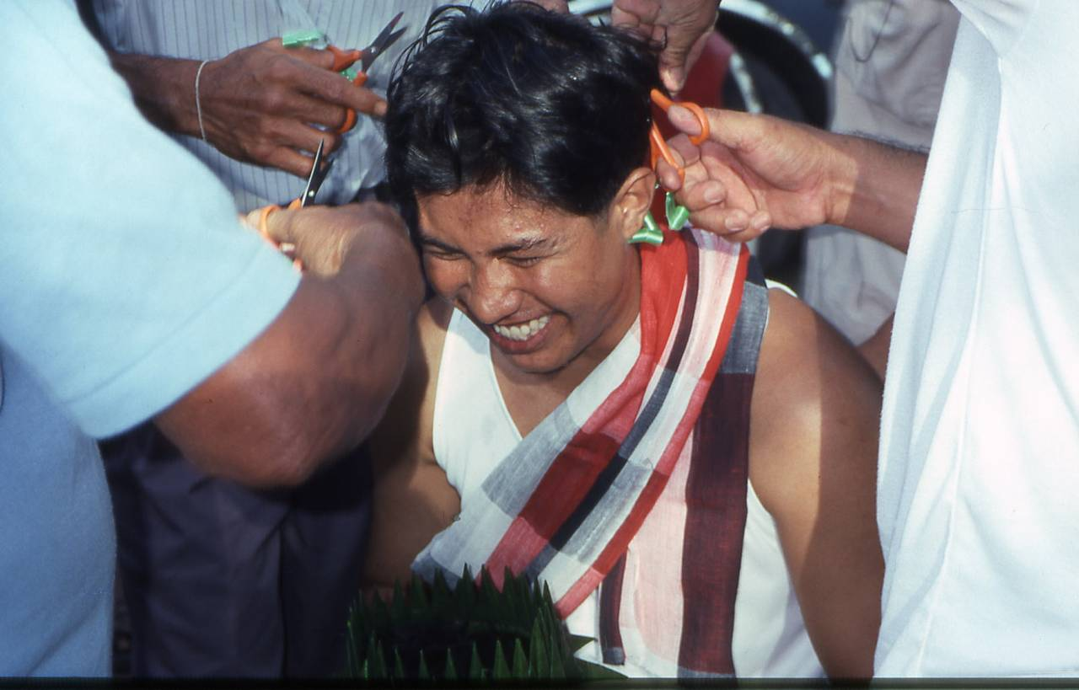

The vows that a person must take before becoming a monk or nun include:
Refraining from killing living beings
Refraining from taking what is not given
Refraining from false speech
Refraining from alcohol
Refraining from eating at the forbidden times
Refraining from dancing, singing, music and going to see entertainments
(Refraining from’ means you won’t do something)

