**Mary, Mother of God topic box**

* Book:  *Mary: Images of the Holy Mother*, by Jacqueline Orsini.
* Book:  *Mary, Mother of Jesus*, by Mary Joslin and Alison Wisenfeld.
* Booklet:  The Rosary for children.
* 15 Christmas cards.
* Two Holy family statues.
* Icon:  Our Lady of Perpetual Succour.
* Information pack.
* Madonna and child statue.
* Six posters various.
* Two rosaries.
* Rosary wooden in red pouch.

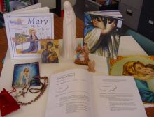

To order the artefact boxes, complete the online form

<http://www3.hants.gov.uk/education/hias/re/artefact-boxes>

or telephone the RE Centre on 01962 863134.