The ordinary people of England risk their lives to save our soldiers at Dunkirk

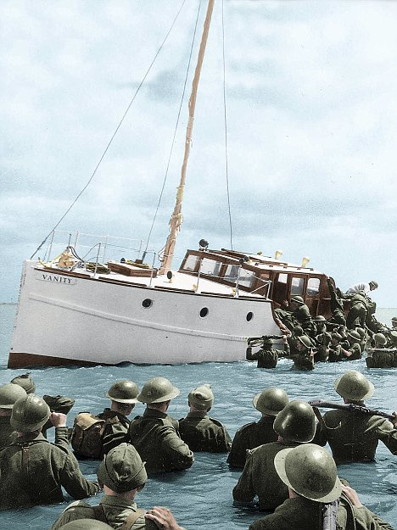

**Soldiers at Dunkirk being rescued by a small boat which had sailed across the Channel through great danger. The owner was a 65-year old man.**

|  |
| --- |
| http://news.bbc.co.uk/shared/img/o.gif |
|  |
|  |

**Zeebrugge heroes honoured 1987**

Belgians and Britons who showed heroism during the rescue operation of the Zeebrugge ferry disaster have been recognised in the New Year's Honours List.

A total of 31 people are to receive honours for helping to save an estimated 350 passengers when the *Herald of Free Enterprise* capsized, near Bruges, on 6 March. 193 people died.

One of the highest civilian awards for bravery, the George Medal, has been awarded to head waiter Michael Skippen who died trying to get passengers to safety.

It also goes to Andrew Parker who formed a human bridge to allow others to clamber to safety across him.

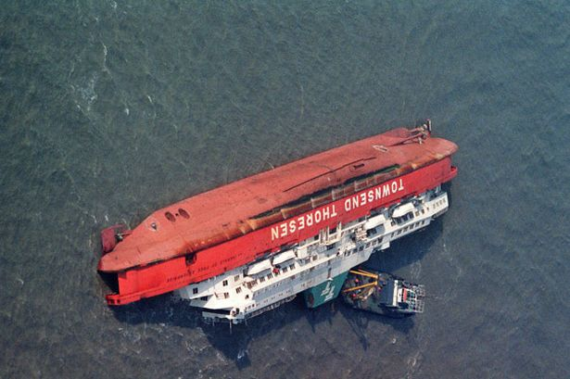

**PILOTS IN WW2**

CONDITIONS:

* continuous darkness for six to nine hours
* 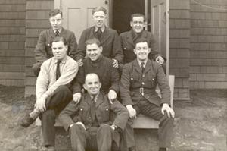cramped plane
* air-sickness
* deafening engine noise
* wearing breathing equipment
* temperatures well below freezing.
* not allowed to use the radio to communicate.

AT ANY MOMENT THE PLANE COULD:

**Sergeant Thomas Earle, Flight Engineer, at front, with the crew of Lancaster MkII DS789/OW"A".**

* break down
* catch fire
* be shot by the enemy

This could cause injury or death OR

* the plane could go down over enemy country
* the chances of escape were slim: they could die as they crashed
* if they survived, they could be captured and tortured
* or imprisoned for the rest of the war.

They all knew that their chance of surviving thirty raids was probably less than 50%: every time that set off they had a 50% chance of being killed.

It is for these it is essential not to forget the sacrifices of these men and many thousands more for our freedom today.

Never in the field of human conflict was so much owed by so many to so few.

All hearts go out to the fighter pilots, whose brilliant actions we see with our own eyes day after day but we must never forget that all the time, night after night, month after month, our bomber squadrons travel far into Germany, find their targets in the darkness by the highest navigational skill, aims their attacks, often under the heaviest fire, often at serious loss, with deliberate, careful precision, and inflict shattering blows upon the whole of the technical and war-making structure of the Nazi power.

*Winston Churchill*



# http://4.bp.blogspot.com/-S0b_I-dMC5Q/T9gqSOuf5RI/AAAAAAAALzk/_r-j5gIDBCo/s1600/motivation,quote,inspiration,james,allen,quotes-5535f1a6292ebabd56739ed0e96be954_h.jpgMan drowns rescuing two children at West Wittering beach

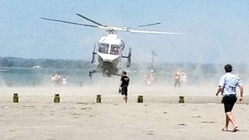

The air ambulance was sent to the scene but the man was pronounced dead on the beach

A 25-year-old man has died on a beach in West Sussex after going to the aid of two children in the sea.

The children were playing in a rubber ring at West Wittering beach "some five metres from the shoreline" on Saturday.

A police spokesman said the man managed to get the children to safety "but in doing so put himself in danger which sadly resulted in him drowning".

The identity of the man has not been released, but police said he was not related to the children.