HAIKUS – 5 – 7 – 5 syllables; title not included but should add to poem

THE BEGINNING OF THE WORLD

Silent nothing waits

C:\Users\Kath\AppData\Local\Microsoft\Windows\Temporary Internet Files\Content.IE5\N1U9A9GN\MC900233776[1].wmfParticles drift from nowhere

A new world is born

IN THE BEGINNING

Cold black emptiness.

Shooting flames erupt and flare.

Something from nothing.

**What was here before?**

No stars, no blue sky

Nothing has been created

Can nothing exist?

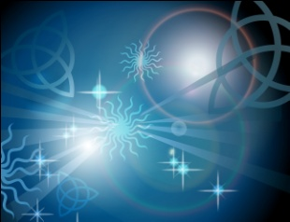

Hello world!

In the twinkly stars

A fragile globe begins to spin

Turning blue and green

C:\Users\Kath\AppData\Local\Microsoft\Windows\Temporary Internet Files\Content.IE5\O4Y1UR9M\MC900276202[1].wmf