**Moses is trying to lead his people, the Israelites, to freedom from the Pharaoh who has kept them as slaves.**

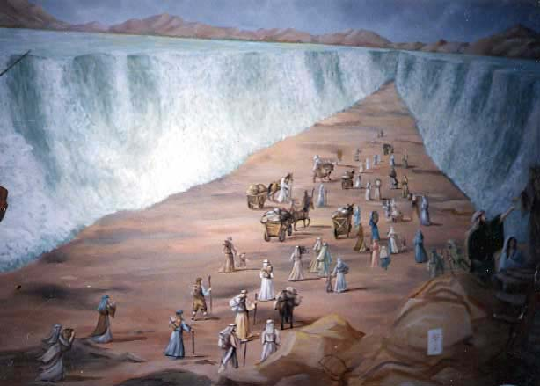Then the LORD said to Moses, “Why are you crying out to me? Tell the Israelites to move on. 16 Raise your staff and stretch out your hand over the sea to divide the water so that the Israelites can go through the sea on dry ground. 17 I will harden the hearts of the Egyptians so that they will go in after them. And I will gain glory through Pharaoh and all his army, through his chariots and his horsemen. 18 The Egyptians will know that I am the LORD when I gain glory through Pharaoh, his chariots and his horsemen.”

19 Then the angel of God, who had been traveling in front of Israel’s army, withdrew and went behind them. The pillar of cloud also moved from in front and stood behind them, 20 coming between the armies of Egypt and Israel. Throughout the night the cloud brought darkness to the one side and light to the other side; so neither went near the other all night long.

21 Then Moses stretched out his hand over the sea, and all that night the LORD drove the sea back with a strong east wind and turned it into dry land. The waters were divided, 22 and the Israelites went through the sea on dry ground, with a wall of water on their right and on their left.

23 The Egyptians pursued them, and all Pharaoh’s horses and chariots and horsemen followed them into the sea. 24 During the last watch of the night the LORD looked down from the pillar of fire and cloud at the Egyptian army and threw it into confusion. 25 He jammed[[b](http://www.biblegateway.com/passage/?search=Exodus+14&version=NIV#fen-NIV-1915b)] the wheels of their chariots so that they had difficulty driving. And the Egyptians said, “Let’s get away from the Israelites! The LORD is fighting for them against Egypt.”

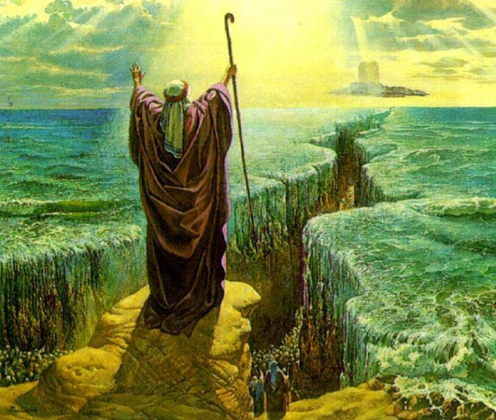 26 Then the LORD said to Moses, “Stretch out your hand over the sea so that the waters may flow back over the Egyptians and their chariots and horsemen.” 27 Moses stretched out his hand over the sea, and at daybreak the sea went back to its place. The Egyptians were fleeing toward[[c](http://www.biblegateway.com/passage/?search=Exodus+14&version=NIV#fen-NIV-1917c)] it, and the LORD swept them into the sea. 28 The water flowed back and covered the chariots and horsemen—the entire army of Pharaoh that had followed the Israelites into the sea. Not one of them survived.

**CHRISTIAN SONGS**

## We Plough The Fields And Scatter

**We plough the fields and scatter  
The good seed on the land,  
But it is fed and watered  
By God's almighty hand:  
He sends the snow in winter,  
The warmth to swell the grain,  
The breezes and the sunshine,  
And soft, refreshing rain.  
  
Refrain:  
All good gifts around us  
Are sent from heaven above;  
Then thank the Lord,  
O thank the Lord,  
For all his love.  
  
He only is the maker  
Of all things near and far;  
He paints the wayside flower,  
He lights the evening star;  
The winds and waves obey him,  
By him the birds are fed;  
Much more to us, his children,  
He gives our daily bread.**

Who put the colours in the rainbow? Who put the salt into the sea?   
Who put cold into the snowflake? Who made you and me?   
Who put the hump upon the camel? Who put the neck on the giraffe?   
Who put the tail upon the monkey? Who made hyenas laugh?   
Who made whales and snails and quails?   
Who made dogs and hogs and frogs?   
Who made rats and bats and cats?   
Who made ev'rything?   
  
Who put the gold into the sunshine? Who put the sparkle in the stars?   
Who put the silver in the moonlight? Who made Earth and Mars?   
Who put the scent into the roses? Who taught the honey bee to dance?   
Who put the tree inside the acorn? It surely can't be chance!   
Who made seas and leaves and trees? Who made snow and winds that blow? Who made streams and rivers flow?

GOD MADE ALL OF THESE!

ALL THINGS BRIGHT AND BEAUTIFUL

*Chorus*

*All things bright and beautiful,  
All creatures great and small,  
All things wise and wonderful:  
The Lord God made them all.*

Each little flower that opens,  
Each little bird that sings,  
He made their glowing colors,  
He made their tiny wings.

*Chorus*

The rich man in his castle,  
The poor man at his gate,  
He made them, high or lowly,  
And ordered their estate.

*Chorus*

The purple headed mountains,  
The river running by,  
The sunset and the morning  
That brightens up the sky.

Look up these Bible passages:

*Chorus*

The cold wind in the winter,  
The pleasant summer sun,  
The ripe fruits in the garden,  
He made them every one.

*Chorus*

The tall trees in the greenwood,  
The meadows where we play,  
The rushes by the water,  
To gather every day.

*Chorus*

He gave us eyes to see them,  
And lips that we might tell  
How great is God Almighty,  
Who has made all things well.

*Chorus*

***Matthew 19:26***

### *Jeremiah 10:12*

***Deuteronomy 32:39***

***Genesis 1***

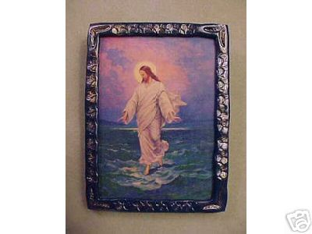

*Shortly before dawn Jesus went out to them, walking on the lake. 26 When the disciples saw him walking on the lake, they were terrified. “It’s a ghost,” they said, and cried out in fear.*

**Matthew 19:26**

*But Jesus looked at them and said,  “With man this is impossible, but with God all things are possible.”*

### 