**The story of the Indra and Indrani**

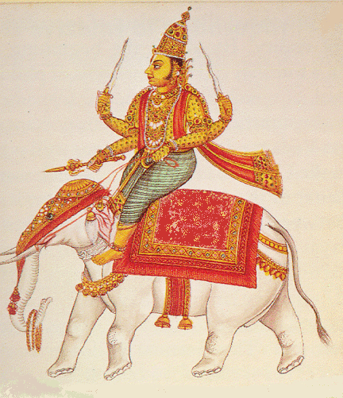The group of the Gods were on the losing side and so Lord Indra was quite worried about the end of the war. He did not what to do. He approached his guru ‘Brihaspati’ and sought advice. At this crucial moment, his Guru Brihaspati asked Lord Indra to get a Rakhi or chasm tied on his wrist by his wife Indrani. He also said this wristlet should be empowered by the sacred mantras chanted on the full moon day or Shravana Purnima.   
  
Thereafter, Indrani or Sachi (Indra’s wife) empowered the thread and tied it on to his hand. The power of this sacred thread called Raksha helped the Gods to win the battle safely. This led to the custom of tying an amulet on a man’s wrist. Today sisters tie Rakhis to their brother’s wrist for protection and pray to God for his well being.