**The quiet heroes: As Dunkirk fell, the medics left to tend the wounded and dying**

*No one writes about them. Their deeds go unsung. Which is why, for this gripping series, two writers decided to track down the awe-inspiring stories of the Army medics who have saved countless lives in recent British wars.*

*This article is about those who stayed behind at Dunkirk to look after patients, knowing the Germans were about to capture them.*

The devastating order came down from on high to the doctors and medics of a British mobile field hospital, fleeing from advancing German tanks in northern France in May 1940.

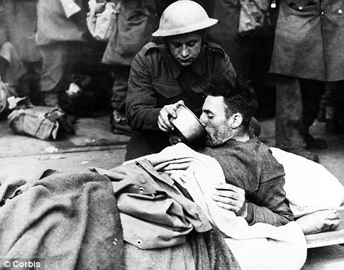They must stay put and surrender. The port and beaches at Dunkirk — the last chance of getting home — were overflowing with wounded soldiers and could take no more.

*Duty and devotion: A British medic helps a wounded man drink at Dunkirk*

‘It is realised that this will mean inevitable capture for you,’ came the message.

So they stayed, knowing they would almost certainly be killed or captured by the Germans. ‘We just carried on as before,’ recalled theatre orderly Private B.C. Miller, ‘easing the pain of the dying and burying the dead.’

Miller and his convoy of ambulances and lorries had reached a small village very close the the Channel when the order to halt arrived. They set up a makeshift operating theatre in a school, laying seven stretchers across the desks as surgical tables. These were in constant use.

Retreating troops passed by in trucks and offered lifts to the coast and the chance of getting home, but they stuck to their task. ‘None of us took advantage of them,’ Miller said. ‘We had a job to do, and we did it.’

All over northern France, medics were grappling with the agonising choice of whether to run for home or remain at their post.

Lieutenant Trevor Gibbens, medical officer of the Ox and Bucks Light Infantry, set up his aid post in the basement of a girls’ school after his battalion was ordered to fight in the rearguard ring around Dunkirk.

German tanks began destroying the four-storey building floor by floor with shells, but he worked on despite the constant rumble of falling masonry overhead.

When it was obvious the defenders could hold out no longer, permission was given for those who could to make a break for it.

Gibbens opted to stay. The wounded were ‘my responsibility’. He was not going to abandon them.

Meanwhile, on the coast, where hundreds of thousands of British soldiers were stalled on the bomb and bullet-scarred beaches waiting for the chance to get away, medical surgery had set up on the promenade of La Panne, near Dunkirk.

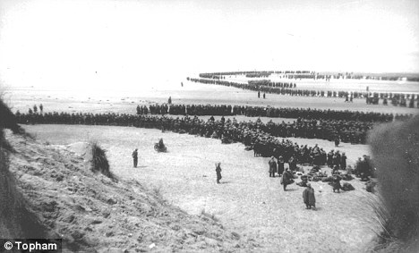The lobbies of the resort’s plush seafront hotels were transformed into giant casualty areas, the floors a carpet of stretchers and wounded men. The kitchens became operating theatres. Every room and corridor was filled with bandaged bodies.

From outside, the sound of guns and bombs shredded what few nerves were still intact, and some patients went mad with fear when German planes roared over.

The noise of hurt, bewildered and angry men was constant. Only the unconscious slept.

*Adapted from a Daily Mail article 19/10/12*