**Apply**

How does the concept affect my life? Is it important to me? What difference does the concept make to my life?

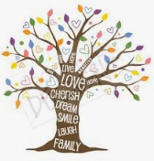

**Communicate**

What am I feeling when I think about the concept? What things in my life are linked with the concept? 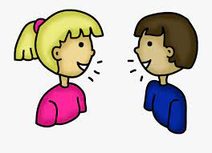

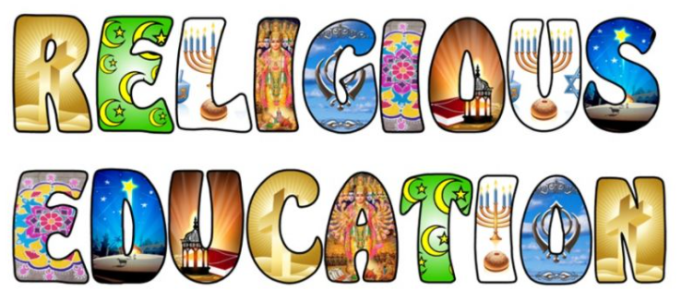

**My journey around the cycle of enquiry**

**Contextualise**

What do religious people do with the concept?

Let’s look at stories, pictures, festivals and artefacts. 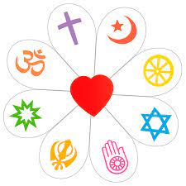

Start here

**Evaluate**

Why is the concept important to the religious people I have learnt about? Why is it important to me?



**Inquire**

What do you think the concept means?

