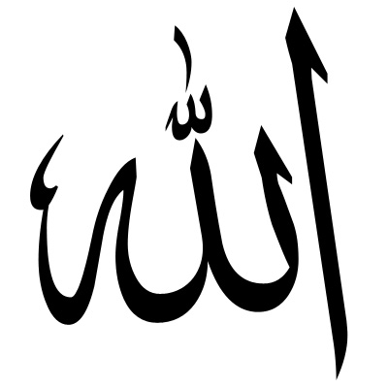

Words from the Qur’an:*“...Allah has power over all things and ... Allah encompasses all things in His knowledge."*(At-Talaq, 65: 12).

*“We* have created all things in due measure. Our command is only one word, like the blinking of an eye. We destroyed those of your kind in the past, but is there any that remembers? Everything they did is in the Books. Everything is recorded, big or small.”* (Al-Qamar, 54: 49-53)

*This means Allah. Allah is referred to as ‘we’ and ‘our’.

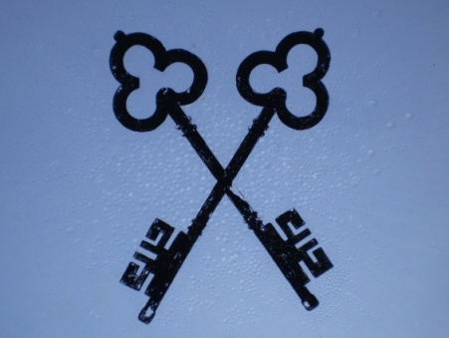

**In the Qur’an, it says:**

**“His Command, when He intends a thing, is only that He says to it, "Be!"–and it is!**}[Ya-Sin 36: 82]

     In other words, if Allah wants something, He merely gives the order. He does not need to repeat His Command or confirm it.

     To Him belong the keys to the heavens and the earth, to Him all things return, and to Him is the Power of creation and command.

     The Verses in the Qur’an that refer to the Power of Allah are too many to count, as are the things he has created: the heavens and the earth, the universe and everything contained in it: galaxies, stars, and planets, among which is our earth.

**From a blog called *Knowing Allah:*** [*http://knowingallah.com*](http://knowingallah.com)