How do Christians celebrate Jesus’ birthday?

C:\Users\Kath\AppData\Local\Microsoft\Windows\Temporary Internet Files\Content.IE5\ROTSHPVD\MC900290067[1].wmf

C:\Users\Kath\AppData\Local\Microsoft\Windows\Temporary Internet Files\Content.IE5\ROTSHPVD\MC900356445[1].wmf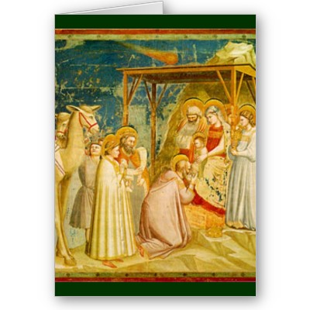C:\Users\Kath\AppData\Local\Microsoft\Windows\Temporary Internet Files\Content.IE5\O4Y1UR9M\MC900305199[1].wmfC:\Users\Kath\AppData\Local\Microsoft\Windows\Temporary Internet Files\Content.IE5\O4Y1UR9M\MC900335794[1].wmf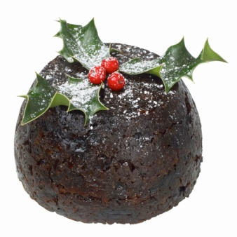C:\Users\Kath\AppData\Local\Microsoft\Windows\Temporary Internet Files\Content.IE5\N1U9A9GN\MC900435448[1].wmfC:\Users\Kath\AppData\Local\Microsoft\Windows\Temporary Internet Files\Content.IE5\O4Y1UR9M\MC900412632[1].wmf