***Who put the colours in the rainbow?***

Who put the colours in the rainbow?  
Who put the salt into the sea?  
Who put the cold into the snowflake?  
Who made you and me?  
Who put the hump upon the camel?  
Who put the neck on the giraffe?  
Who put the tail upon the monkey?  
Who made hyenas laugh?  
Who made whales and snails and quails?  
Who made hogs and dogs and frogs?  
Who made bats and rats and cats?  
God made everything!

**All things bright and beautiful**

All things bright and beautiful,

all creatures great and small,

all things wise and wonderful:

the Lord God made them all.

Each little flower that opens,

each little bird that sings,

God made their glowing colours,

and made their tiny wings.

The purple-headed mountains,

the river running by,

the sunset and the morning

that brightens up the sky.

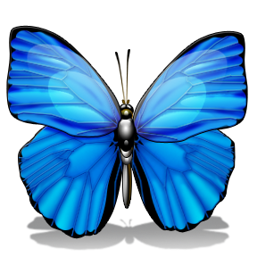

**Away in a manger**

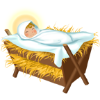Away in a manger,  
No crib for His bed  
The little Lord Jesus  
Laid down His sweet head  
  
The stars in the bright sky  
Looked down where He lay  
The little Lord Jesus  
Asleep on the hay  
  
The cattle are lowing  
The poor Baby wakes  
But little Lord Jesus  
No crying He makes