**AVATAR**

**In computing**

An **avatar** is the graphical representation of the user or the user's alter ego or character. It may take either a three-dimensional form, as in games or virtual worlds, or a two-dimensional form as an [icon](http://en.wikipedia.org/wiki/Computer_icon) in [Internet forums](http://en.wikipedia.org/wiki/Internet_forum) and other online communities. It is an object representing the user. The term "avatar" can also refer to the personality connected with the [screen name](http://en.wikipedia.org/wiki/Screen_name_(computing)), (or handle) of an Internet user.

**The film**

***Avatar*** is a 2009 American [epic](http://en.wikipedia.org/wiki/Epic_film) [science fiction](http://en.wikipedia.org/wiki/Science_fiction) film written and directed by [James Cameron](http://en.wikipedia.org/wiki/James_Cameron). The film is set in the mid-[22nd century](http://en.wikipedia.org/wiki/22nd_century), when humans are mining a precious mineral called [unobtanium](http://en.wikipedia.org/wiki/Unobtainium) on [Pandora](http://en.wikipedia.org/wiki/Fictional_universe_of_Avatar#Astronomy_and_geology), a lush [moon](http://en.wikipedia.org/wiki/Natural_satellite) of a [gas giant](http://en.wikipedia.org/wiki/Gas_giant) in the [Alpha Centauri](http://en.wikipedia.org/wiki/Alpha_Centauri) star system. The expansion of the mining colony threatens the continued existence of a local tribe of [Na'vi](http://en.wikipedia.org/wiki/Na%27vi)—a [humanoid](http://en.wikipedia.org/wiki/Humanoid) species indigenous to Pandora. The film's title refers to the [genetically engineered](http://en.wikipedia.org/wiki/Genetic_engineering) Na'vi-human hybrid bodies used by a team of researchers to interact with the natives of Pandora.

**In Hinduism**

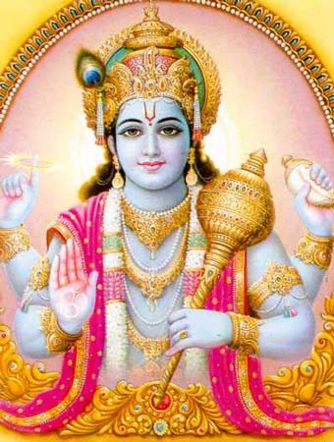In [Hinduism](http://en.wikipedia.org/wiki/Hinduism), an **avatar** [[ˈəvət̪ɑːr]](http://en.wikipedia.org/wiki/Wikipedia:IPA_for_Hindi_and_Urdu) (*avatāra*: [Devanagari](http://en.wikipedia.org/wiki/Devanagari) [अवतार](http://en.wiktionary.org/wiki/%E0%A4%85%E0%A4%B5%E0%A4%A4%E0%A4%BE%E0%A4%B0#Sanskrit), [Sanskrit](http://en.wikipedia.org/wiki/Sanskrit) for "descent" [viz., from heaven to earth]) is a deliberate descent of a [deity](http://en.wikipedia.org/wiki/Deity) from heaven to earth, or a descent of the [Supreme Being](http://en.wikipedia.org/wiki/Supreme_Being) (usually [Vishnu](http://en.wikipedia.org/wiki/Vishnu), although it has also come to be associated with other deities) and is mostly translated into English as "[incarnation](http://en.wikipedia.org/wiki/Incarnation)", but more accurately means "appearance" or "manifestation".

Varying lists of avatars of Vishnu appear in Hindu scriptures, including the ten [Dashavatara](http://en.wikipedia.org/wiki/Dashavatara) of the [*Garuda Purana*](http://en.wikipedia.org/wiki/Garuda_Purana) and the twenty-two avatars in the [*Bhagavata Purana*](http://en.wikipedia.org/wiki/Bhagavata_Purana), though the latter adds that the incarnations of Vishnu are innumerable. An early reference to avatar, and to avatar *doctrine*, is in the [*Bhagavad Gita*](http://en.wikipedia.org/wiki/Bhagavad_Gita).[[5]](http://en.wikipedia.org/wiki/Avatar#cite_note-Sheth-4)

[Sometimes Shiva](http://en.wikipedia.org/wiki/Shiva) and [Ganesha](http://en.wikipedia.org/wiki/Ganesha) are also described as descending in the form of avatars.