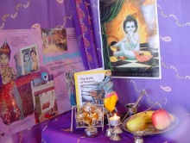**Janmashtami topic box**

* Audio tape:  Hindu music.
* Book:  *Little Krishna*, by Harish Johari, Sapna Johari, Suresh Johari, and Pieter Wettervrede*.*
* Book:  *The birth of Krishna*.
* Information pack: *Janmashtami and Puja*.
* Krishna (butter thief) resin murti.
* Krishna murti.
* Three posters.
* Puja set.

***PLEASE BOOK AS EARLY AS POSSIBLE***

County RE Centre  
Falcon House  
Romsey Road  
Winchester  
SO22 5PL

Tel: 01962 863134

Fax: 01962 842762

E-mail: [re.centre@hants.gov.uk](mailto:re.centre@hants.gov.uk)